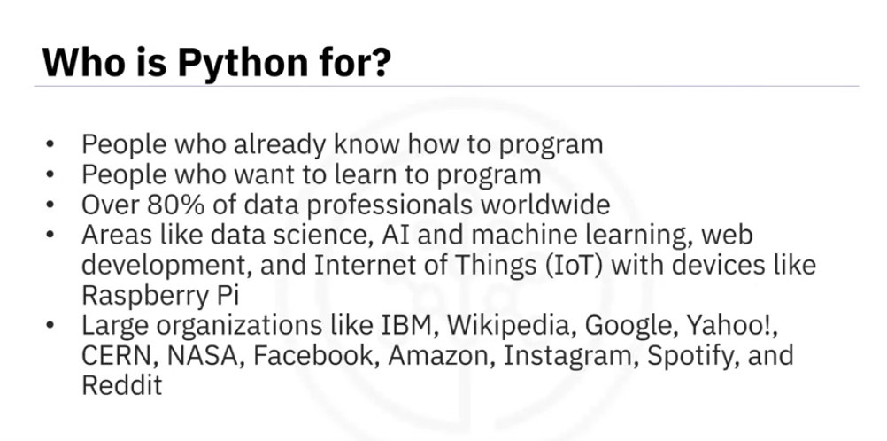

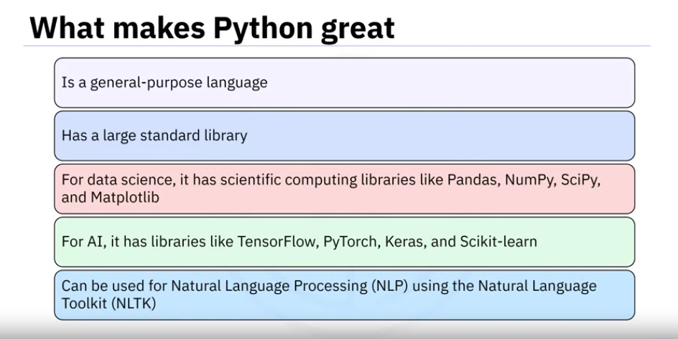

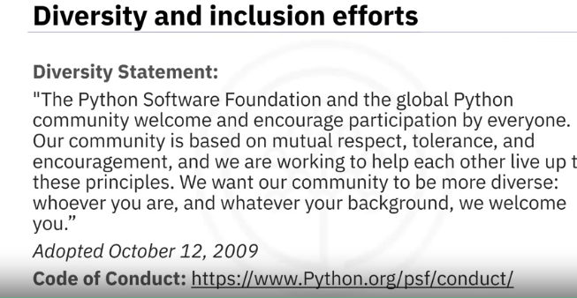

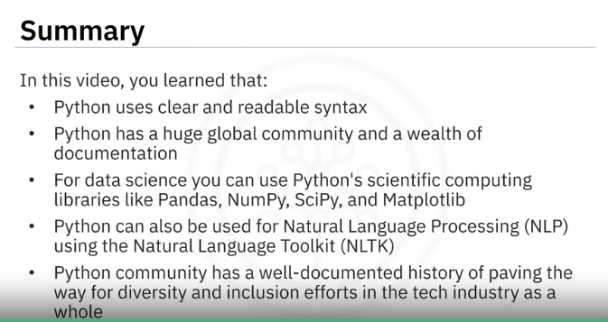

**Introduction to Jupyter**

Jupyter is a freely available web application that enables creation and sharing of documents containing equations, live coding, visualizations, and narrative text. Jupyter provides an interactive computing environment that supports multiple programming languages, including Python, R, Julia, and more, but it shines brightest when used with Python. Jupyter revolves around notebooks, documents containing a mix of code, visualizations, narrative text, equations, and multimedia content. These notebooks allow users to create, share, and collaborate on computational projects seamlessly.

**Why Jupyter?**

Jupyter's popularity stems from its flexibility and ease of use. Regardless of your level of programming expertise, whether you're an experienced coder or embarking on your data science journey, Jupyter offers an intuitive platform for writing, testing, and sharing code. Its interactive interface enables data exploration, algorithm experimentation, and result visualization—all seamlessly integrated within a unified environment.

**Key Features of Jupyter**

Here are some key features and advantages of Jupyter:

1. **Interactive Computing**: Jupyter notebooks enable users to write and execute code interactively. This means you can run code cells individually and see the output immediately, fostering an iterative approach to coding and experimentation.
2. **Support for Multiple Languages**: While Jupyter was initially developed for Python (hence the name, which stands for Julia, Python, and R), it now supports various programming languages through its kernel system. This flexibility makes Jupyter suitable for various computational tasks and interdisciplinary collaboration.
3. **Rich Output**: Jupyter Notebooks support rich media integration, allowing users to generate interactive plots, charts, images, videos, and more directly within the document. This makes visualizing data, communicating findings, and creating compelling narratives easier.
4. **Integration with Data Science Libraries**: Jupyter seamlessly integrates with popular libraries and frameworks used in the data science ecosystem, such as NumPy, Pandas, Matplotlib, sci-kit-learn, TensorFlow, and PyTorch. This allows users to leverage the full power of these tools within the notebook environment for tasks like data manipulation, visualization, machine learning, and deep learning.
5. **Collaboration and Sharing**: Jupyter promotes collaboration and reproducibility by allowing users to share their notebooks with others via email, GitHub, or the Jupyter Notebook Viewer. This facilitates knowledge sharing, peer review, and interdisciplinary collaboration, as users can easily exchange ideas, code snippets, and best practices.

**Jupyter in Data Science**

Jupyter has become an indispensable tool for researchers, analysts, and developers in data science. Its seamless integration with popular libraries such as NumPy, pandas, and sci-kit-learn makes it the go-to choice for data manipulation, analysis, and machine learning. Jupyter provides a user-friendly interface, interactive capabilities, and robust collaboration features, making it an essential tool for anyone involved in data analysis, scientific research, education, or software development. Whether you're exploring data, building machine learning models, teaching a class, or conducting research, Jupyter empowers you to work more efficiently and share your insights with others.

**Getting Started with Jupyter**

Now that you can glimpse what Jupyter offers, it's time to dive in and experience its capabilities firsthand. Our Getting Started with Jupyter video will walk you through the basics of setting up and using Jupyter, empowering you to unleash the full potential of Python and embark on your data science journey with confidence.

So, let's jump into the world of Jupyter and unlock a world of possibilities in Python and data science!

**How we consider Jupyter Notebook is an IDE:**

1. **Interactive Environment**: Jupyter Notebook provides an environment where you can write and execute code interactively. You can run individual code cells and get instant feedback, which makes it highly useful for data exploration and prototyping.
2. **Support for Multiple Languages**: Though it’s mainly used for Python, Jupyter supports other programming languages as well through kernels (like R, Julia, etc.).
3. **Integrated Tools**: Jupyter integrates a text editor, code execution, and output visualization (especially with libraries like Matplotlib, Plotly, etc.), much like a traditional IDE.
4. **Support for Markdown and Visuals**: You can document your code with markdown, add notes, visualizations, and output all within the same interface, creating an all-in-one platform for code and explanations.

**Why Jupyter Notebook is Not Used in Production:**

1. **Not Designed for Robust Production Workflows**: Jupyter is great for experimentation, but it doesn’t have the necessary structure or robustness for production systems, where code needs to be packaged, tested, and deployed in a controlled manner.
2. **Performance Issues**: Since it is designed for interactive coding and not for performance optimization, it can run into issues with memory management, large-scale data processing, and multi-threading, which are crucial in production systems.
3. **No Version Control Support**: Unlike IDEs like Visual Studio Code or JetBrains, Jupyter doesn’t offer direct integration with version control systems (like Git), which is vital for production-grade code collaboration and maintenance.
4. **Lack of Security**: In production, security is a top concern. Running Jupyter notebooks in production might expose your environment to vulnerabilities, especially if you're running it on public-facing servers.
5. **Hard to Deploy**: Jupyter Notebook isn’t designed for continuous integration/continuous deployment (CI/CD) pipelines or large-scale deployments. You need a more structured environment like Docker containers, microservices, or traditional application frameworks for production-grade solutions.